Game Design Document

Fill up the following document

1. Write the title of your project.

Save nature

1. What is the goal of the game?

To teach children to save nature

1. Write a brief story of your game.

Ravi is a boy who lives in kismatpur. All the people of his area throw

Plastic bottles in their surrounding. It can be dangerous for cows if they eat it. Ravi decided to clean his surrounding but there are some insects which can be dangerous to ravi. So,in this game we will save ravi from that insects and help him to do this nobel thing

1. Which are the playing characters of this game?

* Playing characters are the ones who respond to the user based on the input from the user.
* Cars, monkeys, dinos, wizards, etc., are the playing characters in the game.

|  |  |  |
| --- | --- | --- |
| Number | Character Name | What can this character do? |
| 1 | Ravi | Main character |
| 2 |  |  |
| 3 |  |  |
| 4 |  |  |
| 5 |  |  |
| 6 |  |  |
| 7 |  |  |
| 8 |  |  |

1. Which are the Non-Playing Characters of this game?

* Non-Playing characters are the ones that don't have an action or behavior when the user interacts with the game.
* Hurdles, stones, bananas, coins, etc., are non-playing characters in the game.

|  |  |  |
| --- | --- | --- |
| Number | Character Name | What can this character do? |
| 1 | honeybees | bite |
| 2 | fly | bite |
| 3 |  |  |
| 4 | Plastic bottles | Have to collect |
| 5 | coins | Can increase score |
| 6 |  |  |
| 7 |  |  |
| 8 |  |  |

Draw your imagination of this game. What does this game look like?

* Draw the game either on your computer or on paper.
* Add images of the game scenes to show each of the playing and non-playing characters at least once.

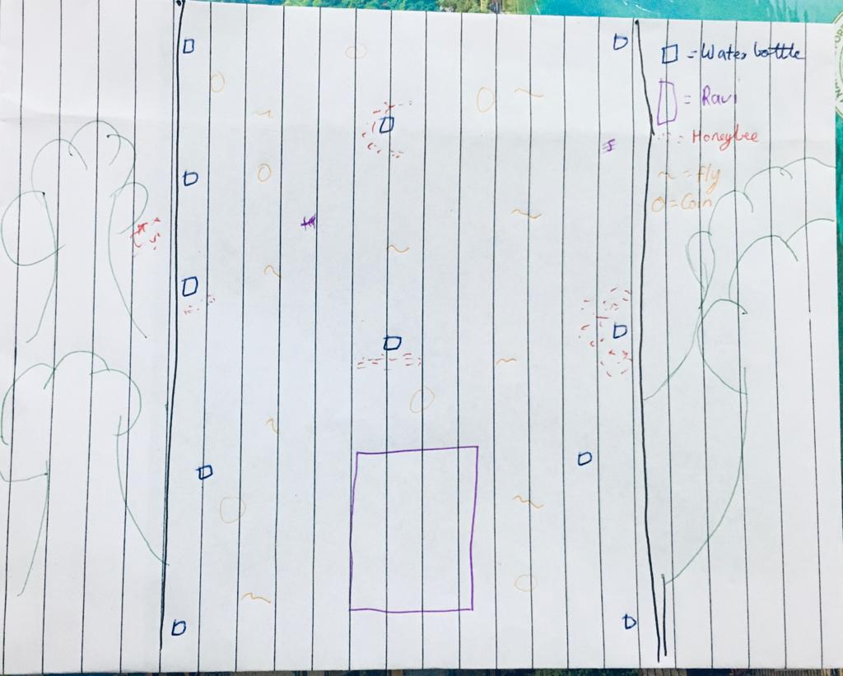

How do you plan to make your game engaging?

by making obstacles